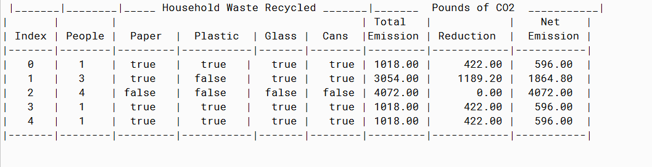

PMR: This program was good review of the arrays we have been learning and was simple to build. In my opinion this program was more simple to build than the previous ones we built in this module. I enjoyed building this program.

/**

* Determines CO2 Emissions from household waste and deductions from recycling activities.

*

* @author Anika Jallipalli

* @version 12/2/2019

*/

import java.util.ArrayList;

public class CO2FromWaste

{

//Initializing variables

private int householdNumber;

boolean paperRecycling,

plasticRecycling,

glassRecycling,

cansRecycling;

double totalWasteEmission,

wasteDeduction,

netWasteDeduction;

//Constructor

CO2FromWaste(int numHousehold, boolean paper,boolean plastic, boolean glass, boolean cans)

{

householdNumber = numHousehold;

paperRecycling = paper;

plasticRecycling = plastic;

glassRecycling = glass;

cansRecycling = cans;

}

/**

* method calculates totalWasteEmission using householdNumber and multiplier figures

*/

public void calcTotalWasteEmission()

{

totalWasteEmission = householdNumber * 1018;

}

/**

* method returns value for totalWasteEmission

*/

public double getTotalWasteEmission()

{

return totalWasteEmission;

}

/**

* method calculates waste deduction from various sorts of recycling activities

*/

public void calcWasteDeduction()

{

double a, b, c, d;

if(paperRecycling == true)

{

a = 184;

}

else

{

a = 0;

}

if(plasticRecycling == true)

{

b = 25.6;

}

else

{

b = 0;

}

if(glassRecycling == true)

{

c = 46.6;

}

else

{

c = 0;

}

if(cansRecycling == true)

{

d = 165.8;

}

else

{

d = 0;

}

wasteDeduction = householdNumber * (a + b + c + d);

}

/**

* method returns value for wasteDeduction

*/

public double getWasteDeduction()

{

return wasteDeduction;

}

/**

* method calculates netWasteDeduction using figures for totalWasteEmission and wasteDeduction

*/

public void calcNetWasteDeduction()

{

netWasteDeduction = totalWasteEmission - wasteDeduction;

}

/**

* method returns value for netWasteDeduction

*/

public double getNetWasteDeduction()

{

return netWasteDeduction;

}

/**

* method returns value for householdNumber

*/

public int householdNumber()

{

return householdNumber;

}

/**

* method returns boolean value for paperRecycling

*/

public boolean getPaperRecycling()

{

return paperRecycling;

}

/**

* method returns boolean value for plasticRecycling

*/

public boolean getPlasticRecycling()

{

return plasticRecycling;

}

/**

* method returns boolean value for glassRecycling

*/

public boolean getGlassRecycling()

{

return glassRecycling;

}

/**

* method returns boolean value for cansRecycling

*/

public boolean getCansRecycling()

{

return cansRecycling;

}

}

**TESTER**

/**

* Determines CO2 Emissions from household waste and deductions from recycling activities.

*

* @author Anika Jallipalli

* @version 12/2/2019

*/

import java.util.ArrayList;

public class CO2FromWasteTester

{

public static void main(String [] args)

{

ArrayList<CO2FromWaste> householdEmission = new ArrayList<CO2FromWaste>();

householdEmission.add(new CO2FromWaste(1, true, true, true, true));

householdEmission.add(new CO2FromWaste(3, true, false, true, true));

householdEmission.add(new CO2FromWaste(4, false, false, false, false));

householdEmission.add(new CO2FromWaste(1, true, true, true, true));

householdEmission.add(new CO2FromWaste(1, true, true, true, true));

CO2FromWaste dataRecord;

for(int index = 0; index < householdEmission.size(); index++)

{

dataRecord = householdEmission.get(index);

dataRecord.calcTotalWasteEmission();

dataRecord.calcWasteDeduction();

dataRecord.calcNetWasteDeduction();

}

System.out.println("|_______|________|_____ Household Waste Recycled _______|_______ Pounds of CO2 ___________|");

System.out.println("| | | | Total | | Net |");

System.out.println("| Index | People | Paper | Plastic | Glass | Cans |Emission | Reduction | Emission |");

System.out.println("|-------|--------|---------|-----------|-------|--------|---------|------------|-----------|");

for(int index = 0; index < householdEmission.size(); index++)

{

dataRecord = householdEmission.get(index);

System.out.printf("|%4d |%4d |%6s |%7s | %6s | %6s | %6.2f | %10.2f |%9.2f |%n",

index, dataRecord.householdNumber(),

String.valueOf(dataRecord.getPaperRecycling()), String.valueOf(dataRecord.getPlasticRecycling()), String.valueOf(dataRecord.getGlassRecycling()), String.valueOf(dataRecord.getCansRecycling()),

dataRecord.getTotalWasteEmission(), dataRecord.getWasteDeduction(),

dataRecord.getNetWasteDeduction());

}

System.out.println("|-------|--------|---------|-----------|-------|--------|---------|------------|-----------|");

}

}